**Facial Expression Detection System**

**Project Synopsis**

MAJOR PROJECT(ICI651)

Degree

**BACHELOR OF COMPUTER APPLICATION**

(CLOUD TECHNOLOGY & INFORMATION SECURITY**)**

|  |  |
| --- | --- |
| PROJECT GUIDE:  **Mr.Arshad Ali** | SUBMITTED BY:  **Tushar Agarwal (TCA2056024)**  **Aashna Ali (TCA2056001)**  **Ritik Gupta(TCA2056019)** |

FEB, 2023



**FACULTY OF ENGINEERING & COMPUTING SCIENCES**

**TEERTHANKER MAHAVEER UNIVERSITY, MORADABAD**

Table of Contents

1 Project Title 3

2 Domain 3

3 Problem Statement 3

4 Project Description 3

4.1 Scope of the Work 3

4.2 Project Modules 4

5 Implementation Methodology 4

6 Technologies to be used 5

6.1 Software Platform 5

6.2 Hardware Platform 5

6.3 Tools 5

7 Advantages of this Project 5

8 Future Scope and further enhancement of the Project 5

9 Team Details 6

10 Conclusion 6

11 References 6

# Project Title

The project title is “**Facial Expression Detection System**”.

The aim of this project is to detect the face and verify that the user is valid.

The main aim of this project is to develop a security tool with an easy to use functionality and high efficiency.

# Domain

**Facial Expression Detection System(Security)**

# Problem Statement

The main objective of this project is to create an facial expression detection system so that it can detect the person and give access to it.

# Project Description

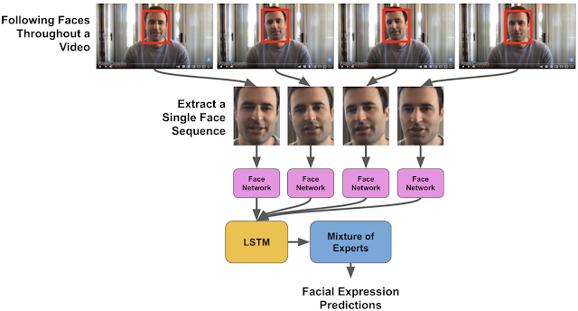

## Scope of the Work

Facial expression recognition software is a technology which uses biometric markers to detect emotions in human faces. More precisely, this technology is a sentiment analysis tool and is able to automatically detect the six basic or universal expressions: happiness, sadness, anger, surprise, fear, and disgust.

## Project Modules

OpenCV: OpenCV is an open-source library in python which is used for computer vision, machine learning, and image processing.

Matplotlib: Matplotlib is a comprehensive library for creating static, animated, and interactive visualizations in Python.

Deepface: Deepface was built by an artificial intelligence researchers group at Facebook. It is a framework in python for facial recognition and attributes analysis. Deepface’s core library components are used in Keras and TensorFlow

# Implementation Methodology

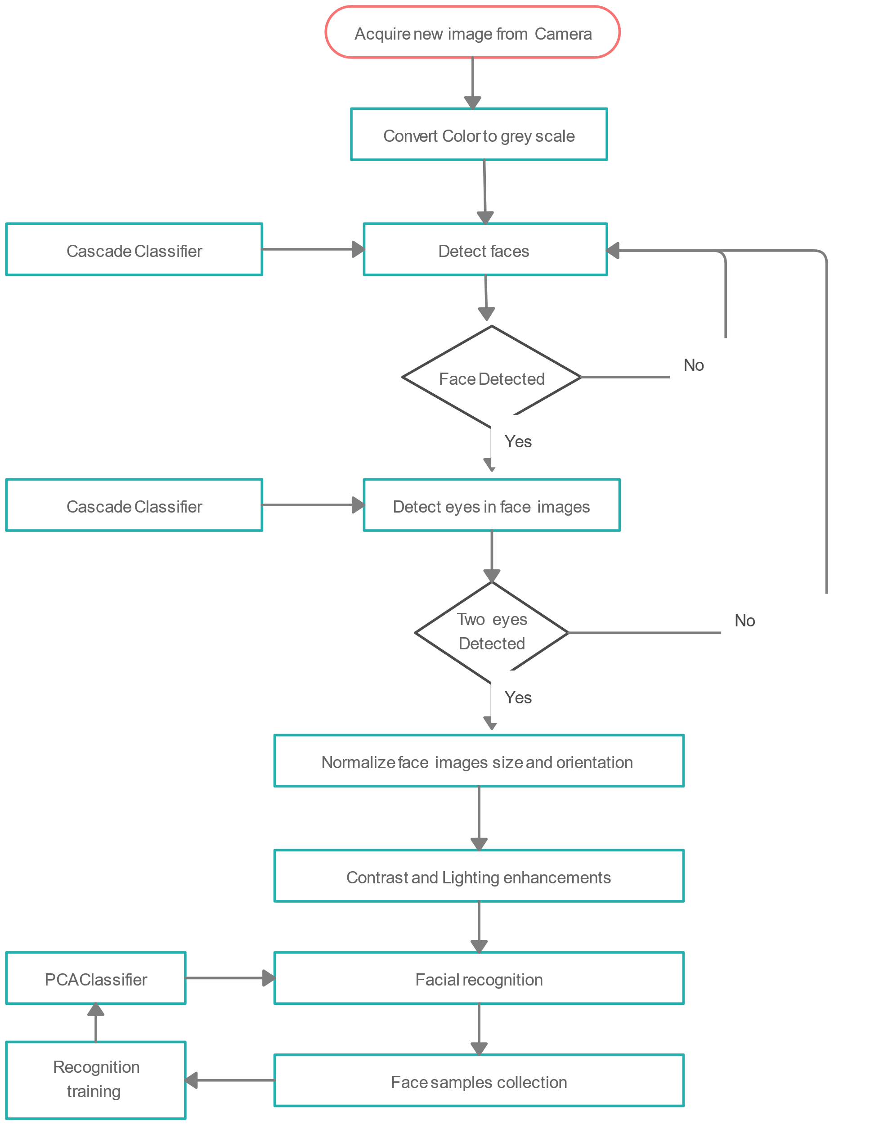

# Technologies to be used

## Software Platform

Python with latest libraries

(a)Deepface

## Hardware Platform

RAM, Hard Disk, OS, Editor, Browser, Working Web Cam etc.

## Tools

Currently in the development phase the main tool is **python 3.10** coder.

Because it already consists all the necessary modules to develop the tool.

# Advantages of this Project

The advantage is that the majority of the picture will return a negative during the first few stages, which means the algorithm won’t waste time testing all 6,000 features on it. Instead of taking hours, face detection can now be done in real time.

# Future Scope and further enhancement of the Project

The Face Recognition (FR) is growing as a major research area because of the broad choice of applications in the fields of commercial and law enforcement. Traditional FR methods based on Visible Spectrum (VS) are facing challenges like object illumination, pose variation, expression changes, and facial disguises. Unfortunately these limitations decrease the performance in object identification and verification. To overcome all these limitations, the Infrared Spectrum (IRS) may be used in human FR. So it leads and encourages the researchers for continuous research in this area of FR. Simultaneously, the present study emphasizes the use of three dimensional cubic dataset i.e. Multi/ Hyperspectral Imagery Data in FR. The IR based Multi/ Hyperspectral Imaging System can minimize the several limitations arise in the existing and classical FR system because the skin spectra derived with cubic dataset depicts the unique features for an individual. Multi/ Hyperspectral Imaging System provides valuable discriminants for individual appearance that cannot be obtained by additional imaging system that's why this may be the future of human FR. This paper also presents a detailed and time to time review of the literature on FR in IRS.

# Team Details

| **Project Name & ID** | **Course Name** | **Student ID** | **Student Name** | **Role** | **Signature** |
| --- | --- | --- | --- | --- | --- |
| **Facial Expression Detection System** | Major Project(ICI651) | TCA2056024 | Tushar Agarwal | Developer, Testing etc. |  |
| TCA2056001 | Aashna Ali | Developer, Testing etc. |  |
| TCA2056019 | Ritik Gupta | Researcher, Tester etc. |  |
|  |  |  |  |
|  |  |  |  |

# Conclusion

Facial expression recognition software is a technology which uses biometric markers to detect emotions in human faces. More precisely, this technology is a sentiment analysis tool and is able to automatically detect the six basic or universal expressions: happiness, sadness, anger, surprise, fear, and disgust.

# References

https://r.search.yahoo.com/_ylt=AwrKByNhqP1jOZYM2CS7HAx.;_ylu=Y29sbwNzZzMEcG9zAzEEdnRpZAMEc2VjA3Ny/RV=2/RE=1677596897/RO=10/RU=https%3a%2f%2fwww.geeksforgeeks.org%2ffacial-expression-recognizer-using-fer-using-deep-neural-net%2f/RK=2/RS=w7.pMmXKx4mWYSChg_aTGsuwQEU-